Explain how AI supports the decision-making process and give one real-world example. (10 marks)
Much AI support can be applied today to the various steps of the decision-making process. Fully automated decisions are common in routine.
Here we follow the steps in the decision-making process
PROBLEM IDENTIFICATION: AI systems are used extensively in problem identification typically in diagnosing equipment malfunction and medical problems, finding security breaches, estimating financial health, and so on. Several technologies are used. For example, sensor-collected data are used by AI algorithms. Performance levels of machines are compared to standards, and trend analysis can point to opportunities or troubles.
GENERATING OR FINDING ALTERNATIVE SOLUTIONS: Several AI technologies offer alternative solutions by matching problem characteristics with best practices or proven solutions stored in databases. Both expert systems and chatbots employ this approach. They can generate recommended solutions or provide several options from which to choose. AI tools such as case-based reasoning and neural computing are used for this purpose.
SELECTING A SOLUTION: AI models are used to evaluate proposed solutions, for example, by predicting their future impact (predictive analysis), assessing their chance of success, or predicting a company’s reply to action taken by a competitor.
IMPLEMENTING THE SOLUTIONS: AI can be used to support the implementation of complex solutions. For example, it can be used to demonstrate the superiority of proposals and to assess resistance to changes.
Applying AI to one or more of the decision-making processes and steps enables companies to solve complex real-world problems
Example: Supporting Nurses’ Diagnosis Decisions
A study conducted in a Taiwanese hospital (Liao, et al., 2015) investigated the use of AI to generate nursing diagnoses and compared them to diagnoses generated by humans. Diagnoses required comprehensive knowledge, clinical experience, and instinct. The researchers used several AI tools, including machine learning, to conduct data mining and analysis to predict the probable success of automated nursing diagnoses based on patient characteristics. The results indicated an 87 percent agreement between the AI and human diagnosis decisions. Such technology can be used in places that have no human nursing staff as well as by nursing staff who want to verify the accuracy of their own diagnostic predictions. The system can facilitate the training of nursing staff as well
Describe the role of machine learning and natural language processing as major AI technologies.
Machine learning
At this time, AI systems do not have the same learning capabilities that humans have; rather, they have simplistic (but improving) machine learning (modeled after human learning) methods. The machine-learning scientists try to teach computers to identify patterns and make connections by showing the machines a large volume of examples and related data. Machine learning also allows computer systems to monitor and sense their environmental activities so the machines can adjust their behavior to deal with changes in the environment. The technology can also be used to predict performance, to reconfigure programs based on changing conditions, and much more. Technically speaking, machine learning is a scientific discipline concerned with the design and development of algorithms that allow computers to learn based on data coming from sensors, databases, and other sources. This learning is then used for making predictions, recognizing patterns, and supporting decision makers.
Machine-learning algorithms are used today by many companies. The process of machine learning involves computer programs that learn as they face new situations. Such programs collect data and analyze them and then “train” themselves to arrive at conclusions. For example, by showing examples of situations to a machine-learning program, the program can find elements not easily visible without it. A well-known example is that of computers detecting credit card fraud.
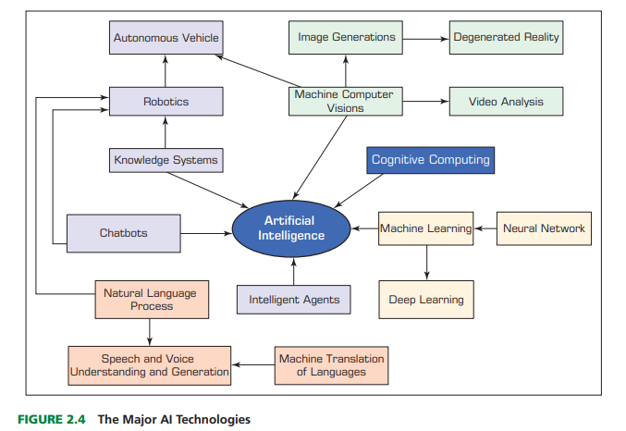
Natural language processing (NLP)
Natural language processing (NLP) is a technology that gives users the ability to communicate with a computer in their native language. The communication can be in written text and/or in voice (speech). This technology allows for a conversational type of interface in contrast with using a programming language that consists of computer jargon, syntax, and commands. NLP includes two subfields:
• Natural language understanding that investigates methods of enabling computers to com prehend instructions or queries provided in ordinary English or other human languages.
• Natural language generation that strives to have computers produce ordinary spoken language so that people can understand the computers more easily
NLP is related to voice-generated data as well as text and other communication forms.
SPEECH (VOICE) UNDERSTANDING: Speech (voice) understanding is the recognition and understanding of spoken languages by a computer. Applications of this technology have become more popular. For instance, many companies have adopted this technology in their automated call centers.
Interpret the challenges and benefits of using AI applications in accounting. (10 marks)
AI in Accounting: overview
The CEO of SlickPie Accounting Software for small businesses, Chandi (2017), noticed trends among professional accountants: their use of AI, including bots in professional routines, increased. Chandi observed that the major drivers for this are perceived savings in time and money and increased accuracy and productivity. The adoption has been rapid and it has been followed by significant improvements. An example is the execution of compliance procedures, where, for instance, Ernst & Young (EY) is using machine learning for detecting anomalous data (e.g., fraudulent invoices).
AI in Big Accounting companies
The big accounting companies use AI to replace or support human activities in tasks such as tax preparation, auditing, strategy consulting, and accountancy services. They mostly use NLP, robotic process automation, text mining, and machine learning.
• EY attempts to show quick, positive return on investment (ROI) on a small scale. The strategy concentrates on business value. EY uses AI, for example, to review legal documents related to leasing (e.g., to meet new government regulations).
• PricewaterhouseCoopers (PwC) favors small projects that can be completely functioning in four weeks. The objective is to demonstrate the value of AI to client companies. Once demonstrated to clients, the projects are refined. PwC demonstrates 70 to 80 such projects annually
All big accounting companies use AI to assist in generating reports and to conduct many other routine, high-volume tasks. AI has produced highquality work, and its accuracy has become better and better with time.
Accounting Applications in small Firms
Small accounting firms also use AI. For example, Crowe Horwath of Chicago is using AI to solve complex billing problems in the healthcare industry. This helps its clients to deal with claims processing and reimbursements. The firm can now solve difficult problems that had previously resisted solutions. Many other applications are used with the support of AI, ranging from analyzing real estate contracts to risk analysis. It is only a question of time before even smaller firms will be able to utilize AI as well.
Job of Accountants
AI and analytics will automate many routine tasks done today by accountants, many of whom may lose their jobs. On the other hand, accountants will need to manage AI-based accounting systems. Finally, accountants need to drive AI innovation in order to succeed or even survive.
Discuss how AI is applied in marketing, advertising, and customer relationship management (CRM). (10 marks)
Compared to other business areas, there are probably more applications of AI in marketing and advertising. For example, AI-based product recommendations have been in use by Amazon.com and other e-commerce companies for more than 20 years. Due to the large number of applications, we provide only a few examples here.
Overview of Major Applications
1. Product and personal recommendations. Starting with Amazon.com’s book recommendations for Netflix’s movies, AI-based technologies are used extensively for personalized recommendations (e.g., see Martin, 2017).
2. Smart search engines. Google is using RankBrain’s AI system to interpret users’ queries. Using NLP helps in understanding the products or services for which online users are searching. This includes the use of voice communication.
3. Fraud and data breaches detection. Application for this has covered credit/debit card use for many years, protecting Visa and other card issuers. Similar technologies protect retailers (such as Target and Neiman Marcus) from hackers’ attacks.
4. Social semantics. Using AI-based technologies, such as sentiment analysis and image and voice recognitions, retailers can learn about customers’ needs and provide targeted advertisements and product recommendations directly (e.g., via e-mail) and through social media.
5. Web site design. Using AI methods, marketers are able to design attractive Web sites.
6. Producer pricing. AI algorithms help retailers price products and services in a dynamic fashion based on the competition, customers’ requirements, and more. For example, AI provides predictive analysis to forecast the impact of different price levels.
7. Predictive customer service. Similar to predicting the impact of pricing, AI can help in predicting the impact of different customer service options.
8. Ad targeting. Similar to product recommendations, which are based on user profiles, marketers can tailor ads to individual customers. The AI machines attempt to match different ads with individuals.
9. Speech recognition. As the trend to use voice in human–machine interaction is increasing, the use of bots by marketers to provide product information and prices accelerates. Customers prefer to talk to bots rather than to key in dialogue
AI Marketing Assistants in Action
There are many ways that AI can be used in marketing. One way is illustrated in Application about Kraft Foods.
The number of mobile users is growing rapidly as is the number of mobile shoppers. Kraft Foods took notice of that. The company is adapting its advertising and sales to this trend. Mobile customers are looking for brands and interacting with Kraft brands. Kraft Foods wanted to make it easy for customers to interact with the company whenever and wherever they want. To achieve this interaction goal, Kraft Foods created a “Food Assistant,” also known as Kraft Food Assistant.
Customer Experiences and CRM
As described earlier, a major impact of AI technologies is changing customer experiences. A notable example is the use of conversational bots. Bots (e.g., Alexa) can provide information about products and companies and can provide advice and guidance. Gangwani (2016) lists the following ways to improve customers’ experiences:
1. Use NLP for generating user documentation. This capability also improves the customer–machine dialogue.
2. Use visual categorization to organize images (for example, see IBM’s Visual Recognition and Clarifai)
3. Provide personalized and segmented services by analyzing customer data. This includes improving shopping experience and CRM.
A well-known example of AI in CRM is Salesforce’s Einstein.
Salesforce Einstein is an AI set of technologies (e.g., Einstein Vision for image recognition) that is used for enhancing customer interactions and supporting sales. For example, the system delivers dynamic sales dashboards to sales reps. It also tracks performance and manages teamwork by using sales analytics. The AI product also can provide predictions and recommendations. It supports Salesforce Customer Successful Platform and other Salesforce products.
Einstein’s automatically prioritized sales leads make sales reps more productive when dealing with sales leads and potential opportunities. The sales reps also get insights about customers’ sentiments, competitors’ involvement, and other information.
Other Uses of AI in Marketing
The following show the diversity of AI technologies used in marketing:
• It is used to mimic the expertise of in-store salespeople. In many physical stores, humans are not readily available to help customers who do not want to wait very long. Thus, shopping is made easier when bots provide guidance. A Japanese store already provides all services in a physical store by speaking robots.
• It provides lead generation. As seen in the case of Einstein, AI can help generate sales leads by analyzing customers’ data. The program can generate predictions. Insights can be generated by intelligent analytics.
• It can increase customer loyalty using personalization. For example, some AI techniques can recognize regular customers (e.g., in banks). IBM Watson can learn about people from their tweets
Explain the concept of intelligent agents and their role in business applications. (10 marks)
Intelligent Agents
An intelligent agent (IA) is an autonomous, relatively small computer software program that observes and acts upon changes in its environment by running specific tasks autonomously. An IA directs an agent’s activities to achieve specific goals related to the changes in the surrounding environment. Intelligent agents may have the ability to learn by using and expanding the knowledge embedded in them. Intelligent agents are effective tools for overcoming the most critical burden of the Internet information overload and making computers more viable decision support tools. Interest in using intelligent agents for business and e-commerce started in the academic world in the mid-1990s. However, only since 2014, when the capabilities of IA increased remarkably, have we started to see powerful applications in many areas of business, economics, government, and services.
Initially, intelligent agents were used mainly to support routine activities such as searching for products, getting recommendations, determining products’ pricing, planning marketing, improving computer security, managing auctions, facilitating payments, and improving inventory management. However, these applications were very simple, using a low level of intelligence. Their major benefits were increasing speed, reducing costs, reducing errors, and improving customer service. Today’s applications, as we will see throughout this chapter, are much more sophisticated
Example 1: Virus Detection Program
A simple example of an intelligent software agent is a virus detection program. It resides in a computer, scans all incoming data, and removes found viruses automatically while learning to detect new virus types and detection methods.
Example 2
Allstate Business Insurance is using an intelligent agent to reduce call center traffic and provide help to human insurance agents during the rate-quoting process with business customers. In these cases, rate quotes can be fairly complicated. Using this system, agents can quickly answer questions posted by corporate customers, even if the agents are not fully familiar with the related issue. Intelligent agents are also utilized in e-mail servers, news filtering and distribution, appointment handling, and automated information gathering
Differentiate between structured and unstructured data with appropriate business examples. (10 marks)
And
Explain the taxonomy of data types and levels of measurement used in analytics. (10 marks)

The term data (datum in singular form) refers to a collection of facts usually obtained as the result of experiments, observations, transactions, or experiences. Data can consist of numbers, letters, words, images, voice recordings, and so on, as measurements of a set of variables
At the highest level of abstraction, one can classify data as structured and unstructured (or semistructured). Unstructured data/semistructured data are composed of any combination of textual, imagery, voice, and Web content. Structured data are what data mining algorithms use and can be classified as categorical or numeric. The categorical data can be subdivided into nominal or ordinal data, whereas numeric data can be subdivided into intervals or ratios.
• Categorical data: These represent the labels of multiple classes used to divide a variable into specific groups. Examples of categorical variables include race, sex, age group, and educational level. Although the latter two variables can also be considered in a numerical manner by using exact values for age and highest grade completed. The categorical data can also be called discrete data, implying that they represent a finite number of values with no continuum between them. Even if the values used for the categorical (or discrete) variables are numeric, these numbers are nothing more than symbols and do not imply the possibility of calculating fractional values.
• Nominal data: These contain measurements of simple codes assigned to objects as labels, which are not measurements. For example, the variable marital status can be generally categorized as (1) single, (2) married, and (3) divorced.
Ordinal data: These contain codes assigned to objects or events as labels that also represent the rank order among them. For example, the variable credit score can be generally categorized as (1) low, (2) medium, or (3) high. Similar ordered relationships can be seen in variables such as age group (i.e., child, young, middle-aged, elderly) and educational level (i.e., high school, college, graduate school). Some predictive analytic algorithms, such as ordinal multiple logistic regression, take into account this additional rank-order information to build a better classification model.
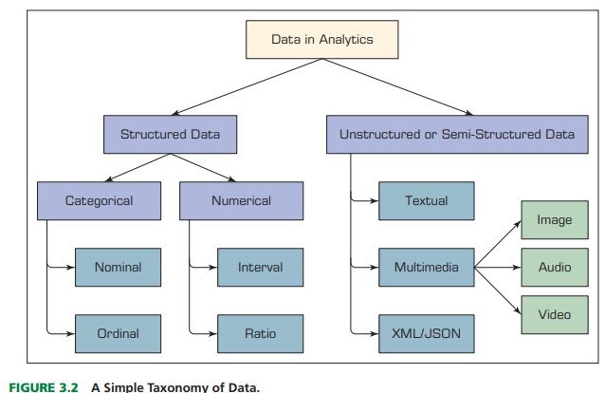
• Numeric data. These represent the numeric values of specific variables. Examples of numerically valued variables include age, number of children, total household income (in U.S. dollars), travel distance (in miles), and temperature (in Fahrenheit degrees). Numeric values representing a variable can be integers (only whole numbers) or real (also fractional numbers). The numeric data can also be called continuous data, implying that the variable contains continuous measures on a specific scale that allows insertion of interim values. Unlike a discrete variable, which represents finite, countable data, a continuous variable represents scalable measurements, and it is possible for the data to contain an infinite number of fractional values.
• Interval data. These are variables that can be measured on interval scales. A common example of interval scale measurement is temperature on the Celsius scale. In this particular scale, the unit of measurement is 1/100 of the difference between the melting temperature and the boiling temperature of water in atmospheric pressure; that is, there is not an absolute zero value.
• Ratio data. These include measurement variables commonly found in the physical sciences and engineering. Mass, length, time, plane angle, energy, and electric charge are examples of physical measures that are ratio scales.
Other data types, including textual, spatial, imagery, video, and voice, need to be converted into some form of categorical or numeric representation before they can be processed by analytics methods (data mining algorithms; Delen, 2015). Data can also be classified as static or dynamic (i.e., temporal or time series).
Illustrate the importance of data preprocessing in analytics with suitable examples. (10 marks)
Data in their original form (i.e., the real-world data) are not usually ready to be used in analytics tasks. They are often dirty, misaligned, overly complex, and inaccurate. A tedious and time-demanding process (so-called data preprocessing) is necessary to convert the raw real-world data into a well-refined form for analytics algorithms (Kotsiantis, Kanellopoulos, & Pintelas, 2006). Many analytics professionals would testify that the time spent on data preprocessing (which is perhaps the least enjoyable phase in the whole process) is significantly longer than the time spent on the rest of the analytics tasks (the fun of analytics model building and assessment). Figure 3.3 shows the main steps in the data preprocessing endeavor.
In the first step of data preprocessing, the relevant data are collected from the identified sources, the necessary records and variables are selected (based on an intimate understanding of the data, the unnecessary information is filtered out), and the records coming from multiple data sources are integrated/merged (again, using the intimate understanding of the data, the synonyms and homonyms are able to be handled properly)
In the second step of data preprocessing, the data are cleaned (this step is also known as data scrubbing). Data in their original form are usually dirty. In this phase, the values in the data set are identified and dealt with. In some cases, missing values are an anomaly in the data set, in which case they need to be imputed (filled with a most probable value) or ignored; in other cases, the missing values are a natural part of the data set. . In this step, the analyst should also identify noisy values in the data (i.e., the outliers) and smooth them out. In addition, inconsistencies (unusual values within a variable) in the data should be handled using domain knowledge and/or expert opinion.
In the third step of data preprocessing, the data are transformed for better processing. For instance, in many cases, the data are normalized between a certain minimum and maximum for all variables to mitigate the potential bias of one variable having large numeric values (such as household income) dominating other variables (such as number of dependents or years in service, which could be more important) having smaller values. Another transformation that takes place is discretization and/or aggregation. In some cases, the numeric variables are converted to categorical values (e.g., low, medium, high); in other cases, a nominal variable’s unique value range is reduced to a smaller set using concept hierarchies
The final phase of data preprocessing is data reduction. Even though data scientists like to have large data sets, too much data can also be a problem. In the simplest sense, one can visualize the data commonly used in predictive analytics projects as a flat file consisting of two dimensions: variables (the number of columns) and cases/records (the number of rows). In some cases, the number of variables can be rather large, and the analyst must reduce the number to a manageable size.
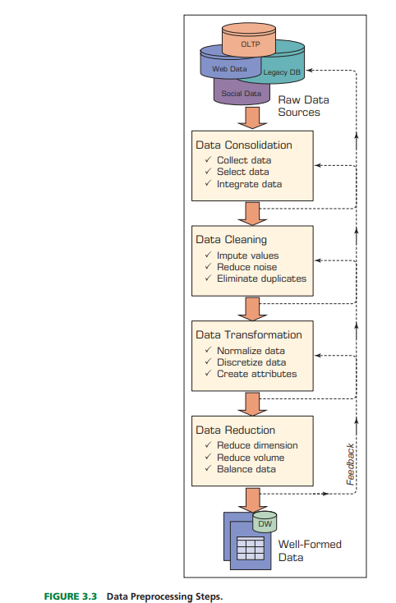

Discuss various techniques of handling missing or inconsistent data in preprocessing. (10 marks)
